Exponential Study Guide
Name:

1) Graph the following functions and identify the key characteristics of the graphs.
Use the domain: $\{ -2, -1, 0, 1, 2\}$

a) $y=3∙{\left(\frac{1}{2}\right)}^{x}$ b) $y=-2^{x}$
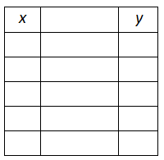
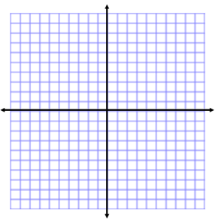
x-intercept: y-intercept: x-intercept: y-intercept:

domain: range: domain: range:

c) $y=3∙{\left(2\right)}^{x}$ d) $y=-2∙{\left(\frac{1}{3}\right)}^{x}$

x-intercept: y-intercept: x-intercept: y-intercept:

domain: range: domain: range:

e) Write the function that would be a reflection across the y-axis for each function.

a) b) c) d)

2) Are the following situations linear, exponential, or neither? Explain your answer. If linear, state the slope. If exponential, state the growth or decay factor.

a) | x | y | b) | x | y | c) | x | y | d) | x | y
 | 1 | 4 |  | -1 | -8 |  | 0 | 28 |  | 0 | 64
 | 2 | 64 |  | 0 | -2 |  | 1 | 18 |  | 1 | 16
 | 3 | 1024 |  | 1 | 4 |  | 2 | 8 |  | 2 | 4
 | 4 | 4096 |  | 2 | 10 |  | 3 | -8 |  | 3 | 1

e) The amount of money you have in your savings account if you deposit $100 each month.

f) The population of a town if the number of people increases by 9% each year.

g) The value of a $100,000 car if it loses half of its value each year.

h) The number of miles you are from home if you drive 70 miles per hour.

3) A colony of mice starts with 5 mice and grows by 20% each year.
- Write the function that represents this situation.

- How many mice will be in the colony after 30 months?

4) You invest $12,000 at a bank that pays an annual interest rate of 1.25%.
- Write the function that represents this situation.

- When would you have at least $15,000 in your account?

5) You buy a tractor for $500. Its value depreciates by 4% each year.
- Choose the function that represents this situation.

- How much is the tractor worth after 12 years?

6) A class starts with 20 people. Every day, two new students are added to the class. Create a table and graph that shows the growth over time.

a) Will this data be best represented by a linear or exponential model? Explain your reasoning.

b) Complete the table and make a graph to represent the growth over time.

c) What is the slope or growth factor for this relationship? What does it represent in the context of the problem?

d) What is the y-intercept for this relationship? What does it represent in the context of the problem?

e) Write the equation the best represents the situation.

f) What is the domain of the situation? Explain your answer.

g) What is the range of the situation? Explain your answer.

7) My bank account starts with $100. Each year I earn 2% interest. Create a table and graph that show the amount of money in the account over time.

a) Will this data be best represented by a linear or exponential model? Explain your reasoning.

b) Complete the table and make a graph to represent the growth over time.

c) What is the slope or growth factor for this relationship? What does it represent in the context of the problem?

d) What is the y-intercept for this relationship? What does it represent in the context of the problem?

e) Write the equation the best represents the situation.

f) What is the domain of the situation? Explain your answer.

g) What is the range of the situation? Explain your answer.

