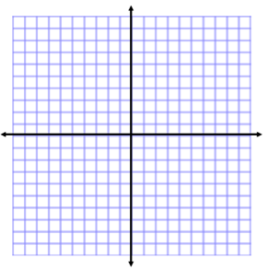
Exponential Funtions
Name:

Exponential Growth:
$$y=a∙{(1+r)}^{x}$$
a = _________________________________
r = _________________________________
x = _________________________________

Exponential Decay:
$$y=a∙{\left(1-r\right)}^{x}$$
a = _________________________________
r = _________________________________
x = _________________________________

Example 1
A town starts with 500 people and grows by 25% every year.
- Write a function that represents this situation.

- How many people would live in the town after 10 years?

Example 2
There are 2 mice in a barn. The number of mice is growing by 40% each year.
- Write a function that represents this situation.

- How many mice are in the barn after 24 months?

Example 3
You invest $1000 at a bank that pays an annual interest rate of 8%.
- Write a function that represents this situation.

- How much is in your account after 15 months?

Example 4
A certain species of monkeys is dying off in a forest each year. The monkey population is currently 24,000 and is projected to decrease by 12% each year.
- Write a function that represents this situation.

- When would the monkey population be extinct?

Exponential Funtions
Name:
Complete the problems below. Graph two of the situations with a detailed graph.

1) Matt bought a new car at a cost of $25,000. Each year, the value of the car depreciates at a rate of 80%.
- Write a function that represents this situation.

- How much is the car worth after 5 years?

2) Jose invests $600 at a bank offering an annual interest rate of 10%.
- Write a function that represents this situation.

2. When would Jose have $5,000 in his account?

3) You invest $2400 at a bank that pays an annual interest rate of 7%.
- Write a function that represents this situation.

2. How much money would you have after 18 months?

4) In 1985, there were 300 cell phone subscribers in the town of Centerville.
The number of subscribers increased by 18% each year.
- Write a function that represents this situation.

2. When would the number of subscribers reach 1,000?

5) You have inherited land that was purchased for $20,000 in 1960. The value of the land increased by a rate of 6% each year.
- Write a function that represents this situation.

2. How much would the land be worth after 35 years?

