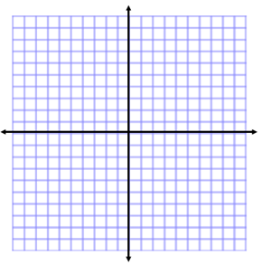
Exponential Functions HW
Name:
Determine if the following tables represent linear or exponential functions. Identify the rate of change or growth factor.
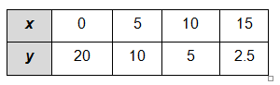
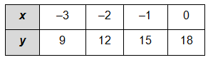
1. 2.

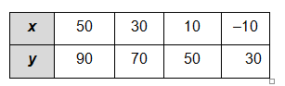
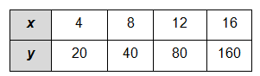
3. 4.

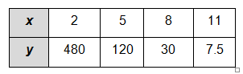
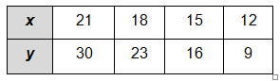
5. 6.

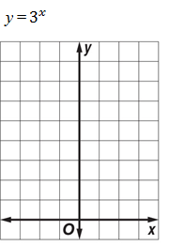
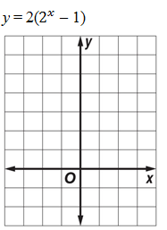
Graph the following exponential equations.
7. 8.

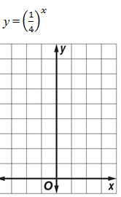
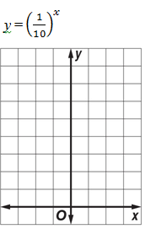
9. 10.

