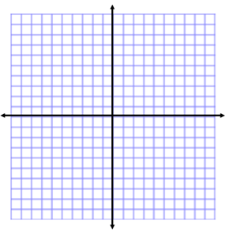
Testing Exponential Functions
Name:
Unit 8 Day 3
Students can:
- Target #5: Discover that exponential functions grow by equal factors over equal intervals.
- Target #6: Classify situations as linear or exponential based on the change between intervals (linear functions change by equal differences and exponential functions change by equal factors

x | y
2
4
5
7
8
10
WARM-UP:
Let’s look at the function $f(x)=.25●2^{x}$
Fill in the table with the missing y values.

MINI LESSON:
We are going to be looking at the intervals from 2 to 4 and from 5 to 7.
Use the function and from the warm-up to fill in the next table.
Interval | Interval Length (difference of two x- values) | Growth (difference of two y-values.) | Growth Factor
2 to 4
5 to 7
8 to 10

So, if we have several cases of equal intervals for our x-values, our growth factor is always _______.

This means that exponential functions grow by ___________ factors over ___________ intervals.

x | y
1
4
5
8
9
12
Let’s try this for one more function using different interval lengths.
Fill in the table with the missing values for the function $f(x)=2●2^{x}$.

Interval | Interval Length (difference of two x- values) | Growth (difference of two y-values.) | Growth Factor
1 to 4
5 to 8
9 to 12

Again, we have equal intervals for x and our growth factors are __________.

x | y
1
4
5
8
9
12
What would the growth look like for a linear function?
Fill in the tables for the function $f\left(x\right)=2x+2$

Interval | Interval Length (difference of two x- values) | Growth (difference of two y-values.) | Rate of change
1 to 4
5 to 8
9 to 12

Now that we know that exponential functions grow by equal factors over equal intervals, and linear functions grow not by a factor, but by a constant rate of change, we should be able to look at a table of values and know if it represents an exponential function.

x | 0 | 1 | 2 | 3
y | 5 | 10 | 15 | 20
1. 2.
x | 0 | 1 | 2 | 3
y | 3 | 9 | 27 | 81

Workshop
x | –1 | 1 | 3 | 5
y | 32 | 16 | 8 | 4
Determine whether the following functions are exponential or linear.
1. 2.
x | –1 | 0 | 1 | 2 | 3
y | 3 | 3 | 3 | 3 | 3

x | –5 | 0 | 5 | 10
y | 1 | 0.5 | 0.25 | 0.125
3. 4.
x | 0 | 1 | 2 | 3 | 4
y | $\frac{1}{3}$ | $\frac{1}{9}$ | $\frac{1}{27}$ | $\frac{1}{81}$ | $\frac{1}{243}$

