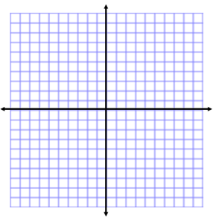
Graphing Exponential Funtions
Name:

WARM-UP:

Match each function with the graph of the function.
- $y=2^{x}$ 2. $y=-\left(2^{x}\right)$ 3. $y= \left(\frac{1}{2}\right)$ ^{x} 4. $y= -\left(\frac{1}{2}\right)$ ^{x}

Evaluate each function for the domain {-2, 0, 2}.
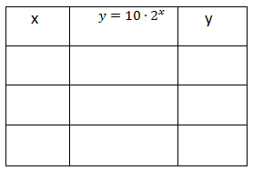
1. 2.
x | $y=2^{x}$ | y

Exponential Function: A function that repeatedly multiplies an initial amount by the same positive number. You can model all exponential functions using y = ab^{x} , where a is a nonzero constant, b > 0, b ≠ 1.

Graph each function.
3. $y=2∙3^{x}$ 4. $y=\frac{1}{2}∙2^{x}$ 5. $y=-\frac{1}{2}∙2^{x}$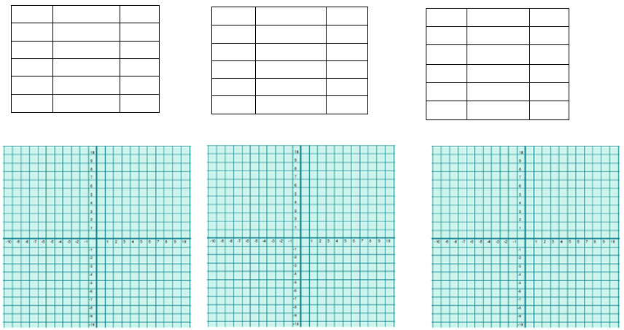
y-intercept: y-intercept: y-intercept:
domain: domain: domain:
range: range: range
6. The function f(x) = 1.25^{x} models the increase in size of an image being copied over and over at 125% on a photocopier. Graph the function.
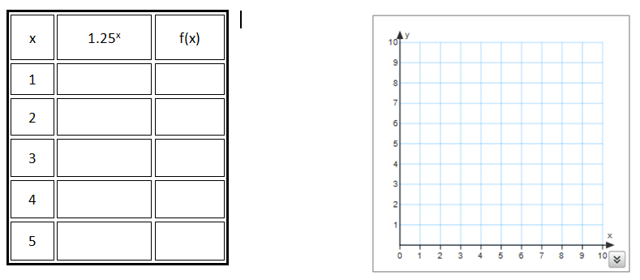

WORKSHOP:
Graph each function.
1. $y=3^{x}$ 2. $y=\frac{1}{4}∙2^{x}$
