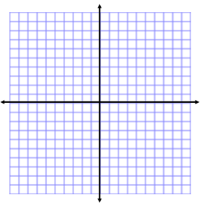
Exponential Funtions
Name:

Students can:
- Target #3: Identify characteristics of exponential functions on the graphs
- Target #4: Use technology to graph and identify characteristics of exponential functions

WARM-UP:
Watch the video on cell division to answer the following questions.
1. In the function $f\left(x\right)=a∙b^{x}$, when b > 1 what does the function do?

2. What does the coefficient (the 1) represent?

3. When the coefficient changed to a 4, how did the GRAPH change?

4. How did the graph change when the base changed from a 2 to a 3?

MINI LESSON:

Go to www.desmos.com and click “Launch Calculator.”

Exponential Functions: $y=a∙b^{x}$

Graph the following functions on the same screen:  $y=2^{x} y=3^{x} y=4^{x}$  Describe how the graphs are different.  What stayed the same? | Graph the following functions on the same screen: $y=1∙2^{x} y={2∙2}^{x} y={3∙2}^{x}$  Describe how these graphs are different.  So the coefficient determines the _______________.

Graph the following functions on the same screen:  $y={\left(\frac{1}{2}\right)}^{x} y={\left(\frac{1}{3}\right)}^{x} y={\left(\frac{1}{4}\right)}^{x}$  Describe how these graphs are different than the first three that we graphed. | Graph the following functions on the same screen:  $y=2^{x} y={\left(\frac{1}{2}\right)}^{x}$  Describe the transformation.  If you don’t see it yet, graph $y=3^{x} \& y={\left(\frac{1}{3}\right)}^{x}$

Graph the following functions on the same screen:  $y=2^{x} y={-2}^{x}$  Describe the transformation.  If you don’t see it yet, graph $y=3^{x} \& y={-3}^{x}$ | Based on the parent function $y=a∙b^{x}$,  A fractional base (b value) causes a reflection across  the ______________________  and a negative coefficient (a value) causes a  reflection across the ______________________.

WORKSHOP:

Use the graphs of the following functions to answer the questions.
1. f$(x)=-2{\left(2\right)}^{X}$ 2. f$(x)=4{\left(\frac{1}{4}\right)}^{X}$
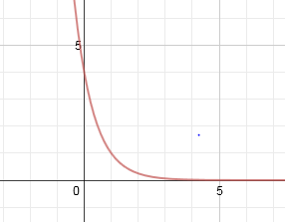
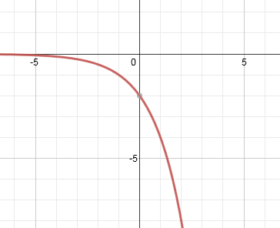

What is the y-intercept? What is the y-intercept?
What is the x-intercept? What is the x-intercept?
What is the domain? What is the domain?
What is the range? What is the range?
What transformations occurred? What transformations occurred?

Draw a quick sketch for each function. Fill in the chart. Describe the transformations.
y=-5^{x}
Sketch: | Domain: | x-intercept:
 | Range: | y-intercept:

3. 5. $y={\left(\frac{1}{6}\right)}^{x}$

6. $y=-{\left(\frac{1}{6}\right)}^{x}$

7. $y=-3{\left(8\right)}^{x}$
y=3(½)^{x}
Sketch: | Domain: | x-intercept:
 | Range: | y-intercept:

4.

8. $y=-2{\left(\frac{2}{7}\right)}^{x}$

