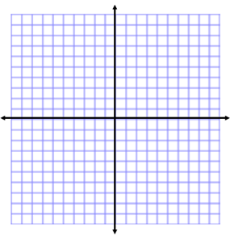
Exponential Funtions
Name:
Unit 8 Day 1 Homework
Given the graph of each function, find the y-intercept and state the domain and range.
1. y = $2^{x}$ 2. y = ${\left(\frac{1}{3}\right)}^{x}$

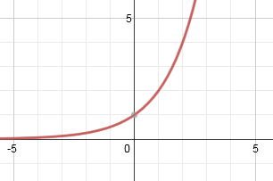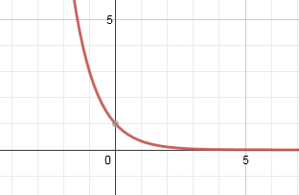

y-intercept: y-intercept:

domain: domain:

range: range:

3. y = 2($2^{x}$) 4. y = -3${\left(\frac{1}{3}\right)}^{x}$

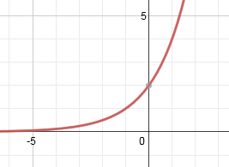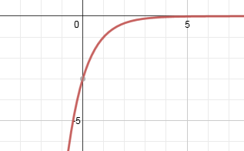
y-intercept: y-intercept:

domain: domain:

range: range:

Describe the transformations that occurred between the following functions & the parent function.
5. $y=-{\left(7\right)}^{x}$ 6. $y=-7{\left(\frac{1}{7}\right)}^{x}$

Evaluate each expression. SHOW YOUR WORK!!!

7. ${25}^{\frac{1}{2}}$ 8. ${1000}^{\frac{2}{3}}$

9. ${121}^{\frac{3}{2}}$ 10. ${\frac{4}{9}}^{\frac{-1}{2}}$

11. ${16}^{\frac{-5}{2}}$ 12. $-{216}^{\frac{-1}{3}}$

13. ${\left(\frac{1}{125}\right)}^{\frac{-1}{3}}$ 14. ${49}^{\frac{-1}{2}}$

15. ${32}^{\frac{3}{5}}$ 16. ${\left(\frac{1}{4}\right)}^{\frac{-1}{2}}$

