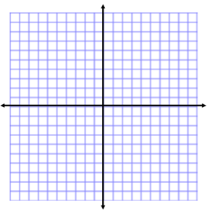
Fitting Functions to Data
Name:

Students can:
- Target #8: Fit a function to data and use functions to solve problems in context of the data

WARM-UP:
1.Evaluate the function 2. Is the data linear? Why? 3.
x | 0 | 3 | 9 | 12
y | 5 | 3 | -1 | -3
$f\left(t\right)={4t}^{2}-4t+12$ for t=3.

Determine if the following tables represent linear, exponential, or quadratic functions. Explain your reasoning.
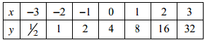
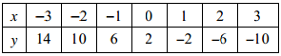
1. 2.

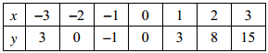
3.

4. A skydiver pulls his chute at 2000 feet above ground. The following table shows his elevation and time as he is falling.
Time (minutes) | Height (feet)
0 | 2000
1 | 1500
2 | 1000
3 | 500
4 | 0
Is the situation a linear, exponential, or quadratic function?

Choose the function that best models the situation.
- $y=-500x+2000$
- $y=-500x^{2}+2000$
- $y=-500^{x}+2000$

What would be the height of the skydiver after 2.5 minutes?

5. Tim Tebow throws a football for a touchdown. The following table shows the height and time for the throw.
Time (seconds) | Height (feet)
0 | 6
1 | 20
2 | 30
3 | 20
4 | 6
Is the situation linear, exponential, or quadratic function?

Choose the function that best models the situation.
- $y=-3x^{2}+18x$
- $y=-3x+18$
- $y={-3}^{x}+18x$

When would the ball be at a height of 15 ft?

WORKSHOP:
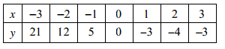
Determine if the following tables represent linear, exponential, or quadratic functions. Explain your reasoning.
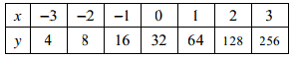
1. 2.

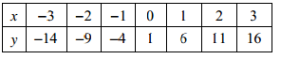
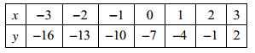
3. 4.

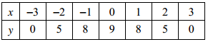
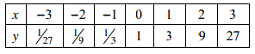
5. 6.

7. A math student throws his math book off of a tall building towards a pool below. The following table shows the height and time of the fall.
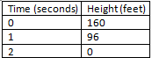
Is the situation a linear, exponential, or quadratic function?

Choose the function that best models the situation.
- $y=-16^{x}+48x+160$
- $y=-16x+160$
- $y=-16x^{2}-48x+160$

How long would it take for the book to fall 100 feet?

8. A helicopter lifts off the ground from a helipad on top of a skyscraper. The following table shows its height along with the time.
Time (seconds) | Height (feet)
0 | 800
1 | 840
2 | 880
3 | 920
4 | 960
Is the situation a linear, exponential, or quadratic function?

Choose the function that best models the situation.
- $y=40x^{2}+800$
- $y=40x+800$
- $y=40^{x}+800$

What would be the height of the helicopter after 7 seconds?

