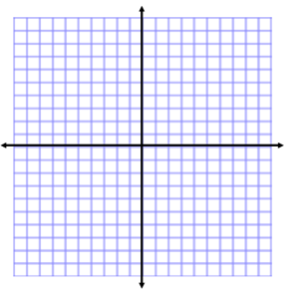
Zeroes of Quadratic Functions
Name:
Solving Quadratics Functions Day 2
Students can:
- Identify zeroes of a factored, quadratic polynomial.
- Use the given zeroes to sketch a graph of a quadratic function.

WARM-UP:
Solve for the roots of the quadratic functions and sketch the graph.

- x² + 9x + 20 2. 9x² – 12x + 4

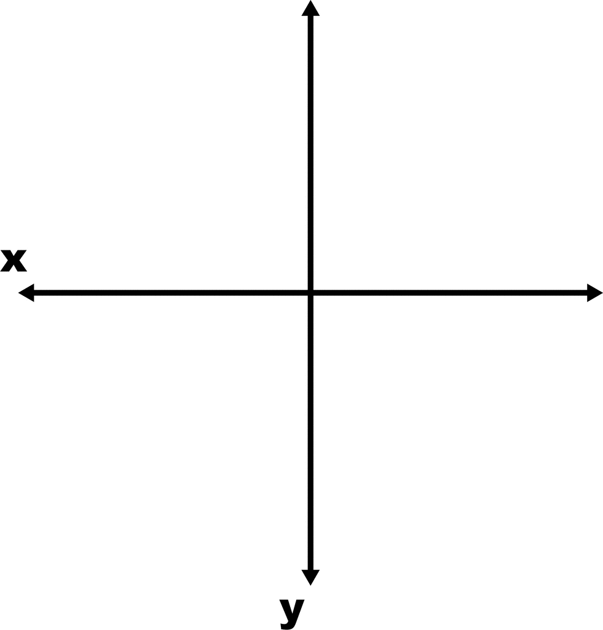

MINI LESSON:

Solve for the x-intercepts for the following quadratic functions. Then sketch the graph.

3. $x^{2}-16=y$ 4. $f\left(x\right)=x^{2}-6x$

5. $y=x^{2}+6x+9$ 6. $f\left(x\right)=2x^{2}+20x+50$

7. How many solutions does each quadratic function have in #3 and #4? ___________
How about in #5 and #6? ___________

8. Sketch a quadratic function that has exactly two solutions.

9. Sketch a quadratic function that has exactly one solution.

10. Sketch a quadratic function that has exactly no solutions.

We can determine the number of solutions a quadratic function has by finding the discriminant. We will practice this next week!

11. T or F? If a quadratic is factorable then it has one or two zeroes.

12. If a quadratic function has exactly one solution, then the solution is the _______________ of the parabola.

WORKSHOP:

Solve for the x-intercepts for the following quadratic functions. Then sketch the graph.

13. $f\left(n\right)=2n^{2}-n-1$ 14. $y=x^{2}+3x+1$

15. $f\left(k\right)={10k}^{2}-35k+ 30$ 16. $y={4x}^{2}-4x-11$

