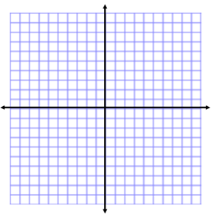
Zeroes of Quadratic Functions
Name:
Solving Quadratics Functions Day 1
Students can:
- Identify zeroes of a factored, quadratic polynomial.
- Use the given zeroes to sketch a graph of a quadratic function.

WARM-UP:
Factor the trinomial. Check your answer.
$$4a^{2}-24a+20$$

MINI LESSON:

Quadratic Function: function with a __________ term, linear term, and constant term.
Examples: $y=4x^{2}+3x+1$ $f(x)=x^{2}+x-100$

Graph of a quadratic function: the graph of a quadratic function will be a _______________(U-shape)

If the coefficient for the quadratic term is positive, the parabola will open _____.
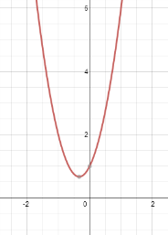
Example: $y=3x^{2}+2x+1$

If the coefficient for the quadratic term is negative , the parabola will open _______.
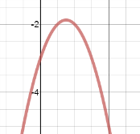
Example: $y=-2x^{2}+3x-3$

Zero: _____-______________ of a quadratic function. (where function intersects __-______)
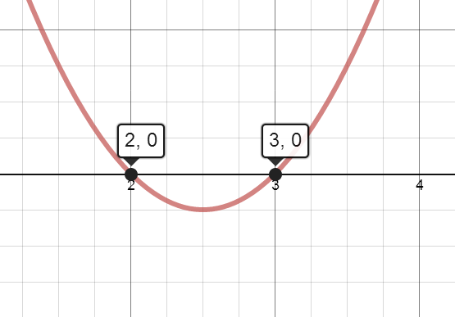

What are the x-intercepts for the given quadratic graph?

What is true about the y-value for any x-intercept?

Steps to solve for x-intercepts:
1. Factor the quadratic polynomial.
2. Substitute zero for ______________.
3. Solve for x using the zero product property.

Zero Product Property:
For any real numbers a and b, if ab=0, then either _____ or ______, or both a and b equal ___.

Solve for the zeroes for the following quadratic functions using the zero product property.
1. $\left(x-2\right)\left(x-3\right)=y$ 2. $\left(2x+4\right)\left(x-2\right)=y$

Solve for the x-intercepts for the following quadratic functions. Then sketch the graph.

3. ${2x}^{2}-2x-24=y$ 4.$f\left(x\right)=3x^{2}-13x+12$

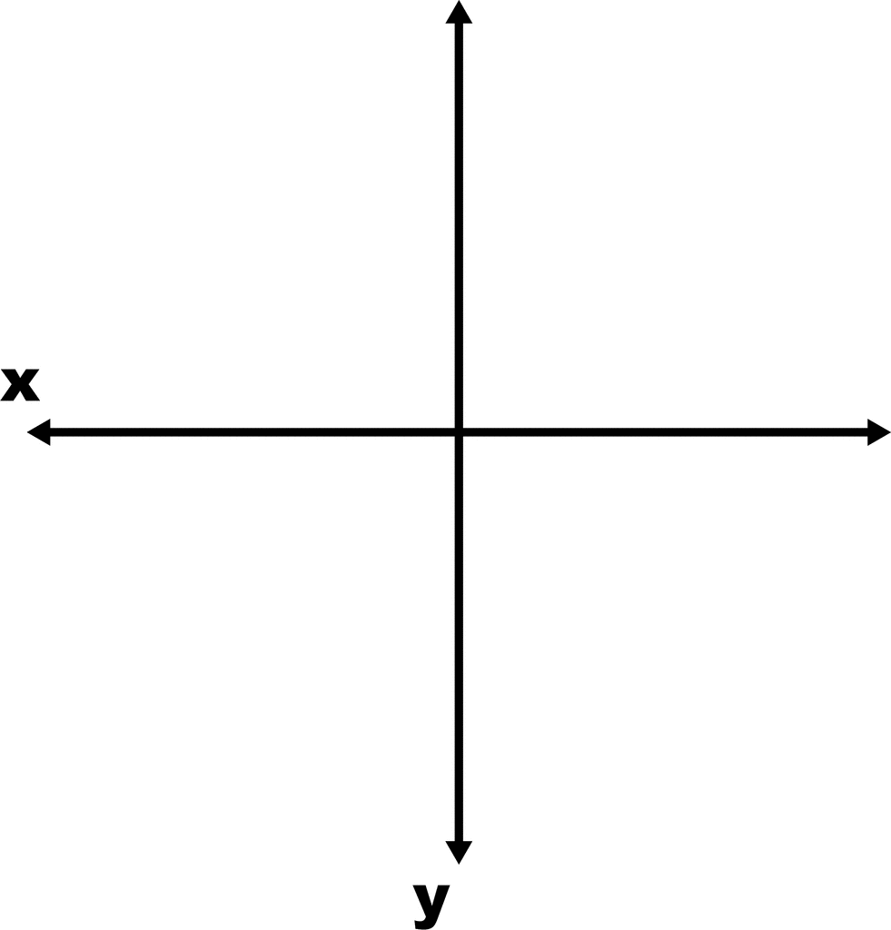

WORKSHOP:
Solve for the zeroes using the zero product property.
1. $\left(4x+16\right)\left(2x-12\right)=y$ 2. $\left(3x-24\right)\left(5x+20\right)=f(x)$

Solve for the x-intercepts for the following quadratic functions. Then sketch the graph.
3. $f\left(x\right)=12x^{2}-12x-72$ 4. $y=x^{2}-16x+64$

