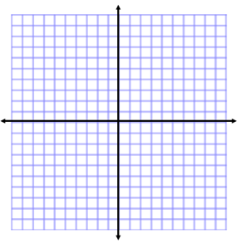
Zeroes of Quadratic Functions
Name:
Unit 9 Day 11
Solve for the x-intercepts (zeroes) for the following quadratic functions. Then sketch the graph.
1. $\left(x+1\right)\left(x-5\right)=y$ 2. $\left(x+1\right)\left(x+2\right)=f(x)$

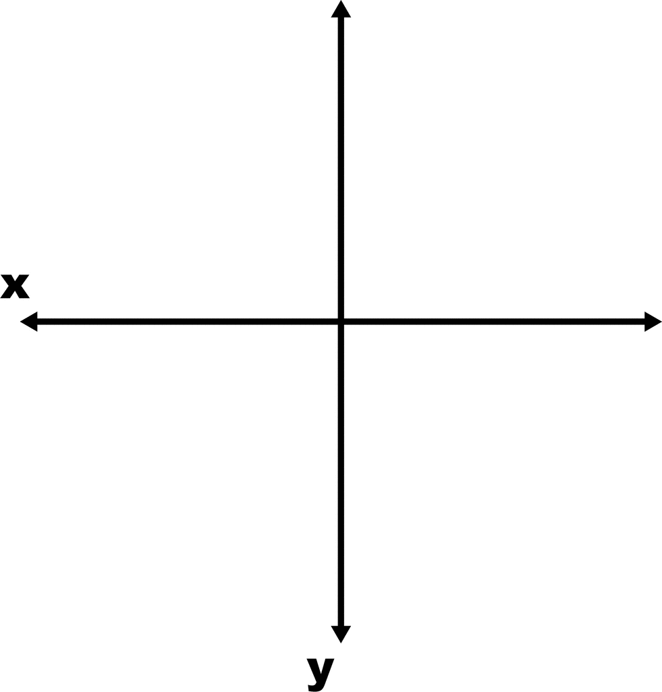

3. $\left(4x+5\right)\left(x+1\right)=y$ 4. $\left(2x+3\right)\left(4x+3\right)=f(x)$

5. $x^{2}-11x+24=y$ 6. $x^{2}+7x+10=f(x)$

7. $x^{2}-10x+24=f(x)$ 8. $x^{2}+3x-18=y$

9. $6x^{2}-18x-24=y$ 10. $7x^{2}-14x+7=f(x)$

11. $x^{2}+8x+15=f(x)$ 12. $5x^{2}-55x+150=y$

13. $3x^{2}-16x-12=y$ 14. $6x^{2}-13x+6=f(x)$

