Ussain Bolt: Rate of Change Introduction Name:_________________________
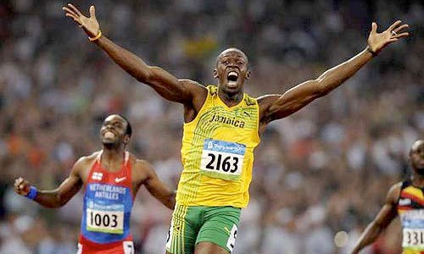
What's the question.

Estimates:
TOO LOW: Guess: TOO HIGH:

Given Information:

Answer the Question:

Identify:
Independent Variable Dependent Variable

Create a table of values. Graph this relationship. Label!

Equation:

Assume Ussain Bolt could maintain this same speed from our school to Chicago. How long would it take him to get there?

a) Solve using your equation

b) Solve using another method of your choice. Show or explain your method.

Assume Ussain Bolt could maintain this same speed for 3 hours. Could he leave the State of Illinois?
a) Solve using your equation.

