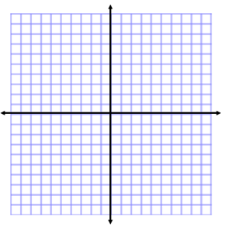
Quadratic Formula Day 1
Name:
Unit 11 Day 2
Students can:
- Target #4: solve quadratic equations by using the quadratic formula

WARM-UP:
Solve by factoring. How do you know where to put each number in the diamond?
1. $x^{2}+8x+16=0$

MINI LESSON:

Not all quadratic equations can be factored. Thus we need
to know other methods to solve them. When we used
Quadratic Formula:

$x=\frac{-b ± \sqrt{b^{2}-4ac}}{2a}$

The $x$ is whatever variable is in the problem.
completing the square, the leading coefficient was equal to one.
It does not need to be equal to one with today’s method.

To use today’s method, the Quadratic Formula, equations
will need to be in Standard Form: $ax^{2}+bx+c=0$

We will plug numbers in for the a, b, and c values.

Use the Quadratic Formula to solve each equation.

1. $x^{2}+6=5x$ 2. $-16t^{2}+47t+3=0$

3. ${4m}^{2}-12m=-9$ 4. $a^{2}-5a+9=0$

5. The length of a rectangle is 5 cm longer than twice its width. The area of the rectangle is 403 cm².
Find the dimensions of the rectangle.

WORKSHOP:
Solve each equation using the Quadratic Formula.
1. $k^{2}-2k+8=16$ 2. $0=2x^{2}+5x+3$

3. $84=5r^{2}+16r$ 4. $3q^{2}+7q+2=0$

5. $8r^{2}+6r=-5$ 6. $0=8g^{2}+10g+3$

7. The base of a triangle is 11m more than 6 times its height. The area of the triangle is 5m².
Find the height of the triangle.

HOMEWORK:

