Exponential Functions Review Name:_______________________Hour:_____

Graph the following function.
$y=2∙{\left(\frac{1}{2}\right)}^{x}$ a) What is the x- intercept?
b) What is the y-intercept?

c) What is the growth factor?

d) What is the domain?

e) What is the range?

2) Use the table to determine if the situation represents a linear or exponential function. Write the equation that matches the data making sure to identify each part of the equation.

a) | x | y | b) | x | y
 | 0 | 100 |  | 0 | -6
 | 1 | 300 |  | 1 | -3
 | 2 | 900 |  | 2 | 0
 | 3 | 2700 |  | 3 | 3

3) Write the equation from the graph making sure to identify each part of the equation.
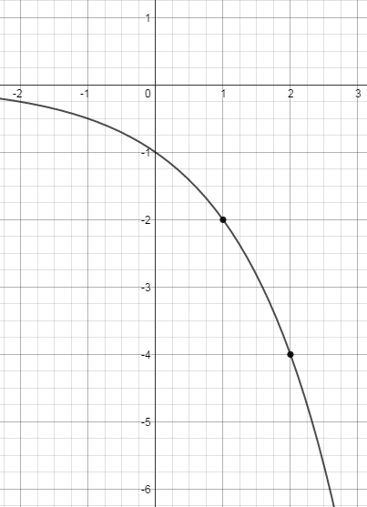
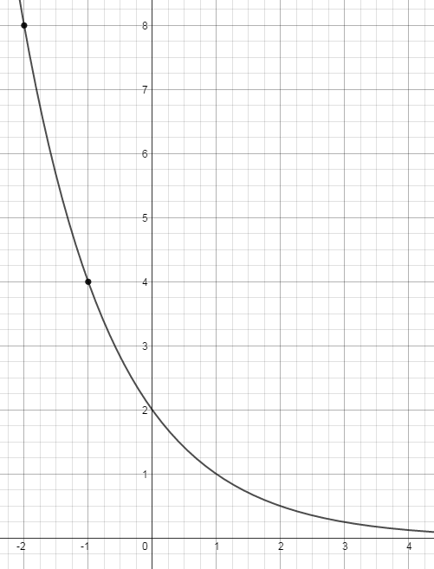
a) b)

4) Make a table and write a function to model the situation.
A restaurant averages 75 customers after making some much needed changes ownership sees that the average number of customers is tripling every month. If this trend continues how many customers will they 11 months.

Bonus: Make a table and write a function to model the situation.
Billy has $1000 in an investment account. He makes 7% every year on the money in his account. Find how much money he will have in his account after 30 years.

