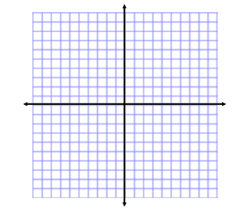**Barbie Bungee Jump**

Name:

What is the relationship that needs to be considered when building a bungee jump for a Barbie Doll?

Make a quick sketch of the relationship.

Write down the strategy your group plans to use to create your bungee jump using the supplies listed.

Before you begin make an official guess to how many rubber bands will be

needed to make the best Barbie Bungee Jump.

Official Guess

Barbie Bungee Resource Page

<http://bit.ly/1DTDADh>

**Tools**

|  |  |
| --- | --- |
|  |  |
|  |  |
|  |  |
|  |  |
|  |  |
|  |  |
|  |  |



**Barbie Bungee Jump Analysis**

Name: