Name ____________________
Algebra I/Block Spring Final Review (2015)

Scatterplots & Line of Best Fit:

1. Look at the data in the table below. Describe the slope of the line of best fit?

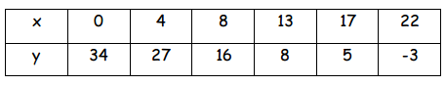

2. Draw and write the equation for the line of best fit. Give two reasons why your line is accurate.

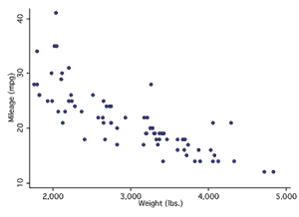

Use the scatterplot below to answer the following questions.

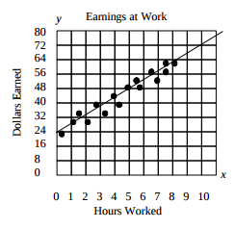

3. According to the line of fit, when Jim’s hours increase by 5, how much do his earnings increase?

4. Which equation best represents the line of best fit?

a. $y=24x-8$ c. $y=8x+24$

b. $y=\frac{1}{8}x+24$ d. $y=24∙8^{x}$

5. Using your line of fit predict how many dollars Jim will earn for working 10 hours.

Quadratics:

Equation A Equation B Equation C Equation D

y = 4(x - 4)² +2 y = -2(x – 3)(x + 2) y = 4x(x - 4)² + 2 y = x² + 2x - 4

Fill in the blanks for the following statements using the equations above.

6. Equation ____ is in vertex form because________________________________________.

7. Equation ____ is in standard form because______________________________________.

8. Equation ____ is in intercept form because______________________________________.

9. Write the equation of the parabola that is the same width except it opens down as the parent graph and has x-intercepts of 4 and -2.

10. Write the equation of the parabola that has an ‘a’ value of 2 and a vertex of (3, -4).

For questions 11-14, Match the graph to its equation.

a. b. c. d.
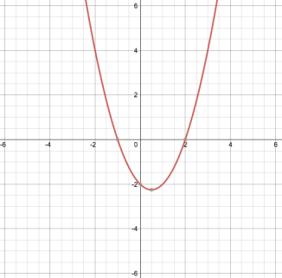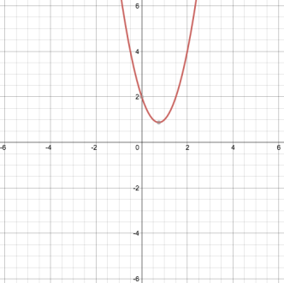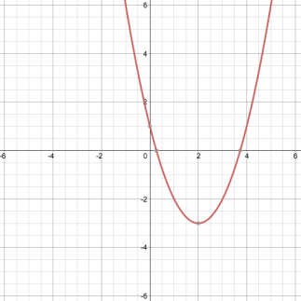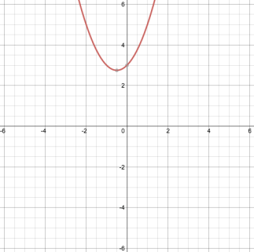

11. y=(x-2)(x+1) 12. y=(x-2)²-3 13. y=2x²-3x+2 14. y=x²+x+3

15. Identify the vertex of the following equation: y=(x-3)²-4
a. (-3, 4) b. (-3, -4) c. (3, -4) d. (3,4)

16. Identify the x-intercepts of the following equation: y=(x-3)(x-4)
a. (0, 3)) and (0, 4)
b. (3, 0) and (-4, 0)
c. (0,3) and (-4, 0)
d. (0, -3) and (0, -4)

17. Identify the y-intercept of the following equation: y=4x²-3x-1
a. (0, -1) b. (-1, 0) c. (1, 0) d. (0, 1)

18. The equation, y=2x²+35x-41 is written in __________________form.
a. quadratic
b. intercept
c. standard
d. vertex

19. Name the vertex of the following equation: y=x²-6x+5
a. (-3, -4) b. (3, -4) c. (-3, 4) b. (-4, 3)

20. Pick the best answer to finish the sentence.
To compress a graph it is necessary for

a. a<1 b. a>1 c. c>1 d. a=1

21. Read the mathematical statement below and decide if it is true or false. If it is true, show work to support the statement. If it is false, correct it.

(4-3x)² = 16 – 9x²

22. Simplify the polynomials.

- (2x + 5)²

- (1-x)²

- (7x – 2)² + 10

23. The function y = x² + 5x – 36 is written in _______________________ form. Put it in intercept form and identify p and q.

Intercept form of this quadratic function: ___________________________

p = ______

q = ______

24. The function y = (x+6)² - 4 is written in _______________________ form. Put it in standard form and identify a, b, and c.

Standard form of this quadratic function: ___________________________

a = ______

b = ______

c = ______

25. The function y = (x - 10)(x – 2) is written in _______________________ form. Put it in standard form and identify a, b, and c.

Standard form of this quadratic function: ___________________________

a = ______

b = ______

c = ______

26. Factor out the GCF to factor the polynomial. 4a² – 12a

27. A polynomial can be represented by the sum of the areas and product of the binomials in the area model below. Write the polynomial in simplest form (sum) and factored form (product).

r² | 9r
-3r | -27

Sum: Product:

28. Factor 2x² -5x +20x – 50.

29. Consider the quadratic expression x² + ?x +25. Select the statement that is true for the values of “?” below.

- ? = 24
- ? = 26
- ? = -10
- ? = 10

- I is the only possible value of “?”.
- I and II are the only possible values of “?”.
- II and IV are the only possible values of “?”.
- II, III and IV are the only possible values of “?”.
- I, II, III, and IV are all possible values of “?”.

30. True or False. When using the AC method, you find the product a and c because b is the sum of the factors of (a⋅c).

31. Factor each completely.

- n² - 8n - 20

- 5x² – 18x + 9

- a² – 8a + 16

- k² – 36

- 6x² – 6x – 72

32. Solve 2x² + 5x – 12 = 0.

33. Solve 2m² – 3m – 3 = 0.

34. Match the graph, function, discriminant, and number of solutions together.
Graph: a. b. c.
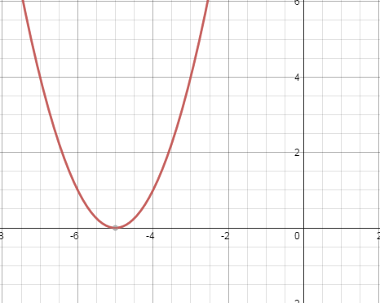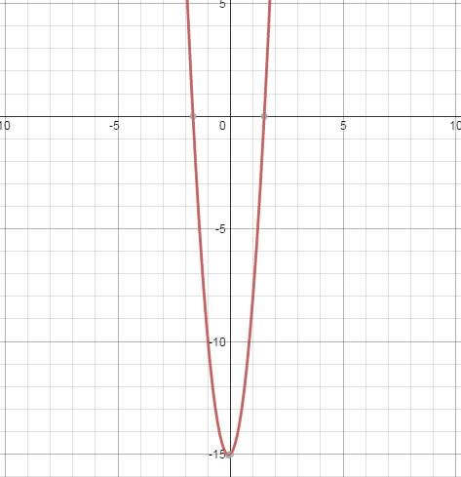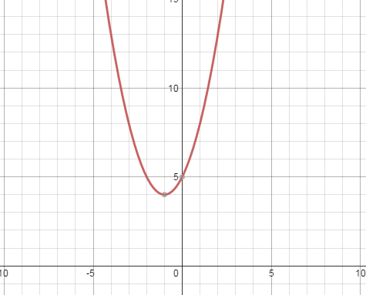
Function:
i. y = x² + 2x + 5 ii. y = 6x² + x - 15 iii. y = x² + 10x + 25

Discriminant:
1. 361 2. -16 3. 0

Number of Solutions:
* 1 ** 2 *** none

35. A number squared is 64 less than 20 times the number. Find the number.

36. The width of a rectangle is 7 inches more than the length. The area of the rectangle is 78 sq. inches. Find the length and the width.

37. A picture is 9 inches by 12 inches. A frame of uniform width is place around the picture. The area of the picture and frame combined is 270 sq. inches. Find the dimensions of the frame.

Radicals:

Simplify.
38. $\sqrt{144}$ 39. $\sqrt{200}$

Graph.
40. y= -2$\sqrt{x}$+ 3

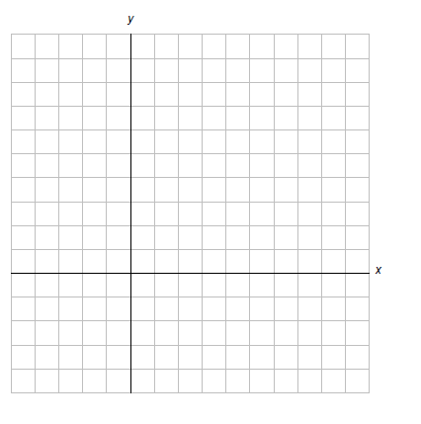

Solve.
41. -2$m^{2}$= -98 42. 5$n^{2}$+11 = 36

Find the missing side of the right triangle.
43. 44. 17 m

7m
19m
9m

Exponentials:

45. Make a table and graph the function y=4($\frac{1}{2}$)^{x} then answer the questions that follow.

x | y

- What is the y-intercept? _____________
- What is the x-intercept? _____________
- What is the domain? _________________
- What is the range? _________________
- What is the horizontal asymptote? ____________

46. Fill in the table with the information you know about linear, quadratic, and exponential functions.

 | Example of a Function | Characteristics of the Table | Example of a Graph
Linear
Quadratics
Exponential

47. Match each graph to its equation.

a) y = 2(3)^{x} b) y = 3(2)^{x} c) y = 2($\frac{1}{3}$)^{x} d) y = 3($\frac{1}{2}$)^{x}

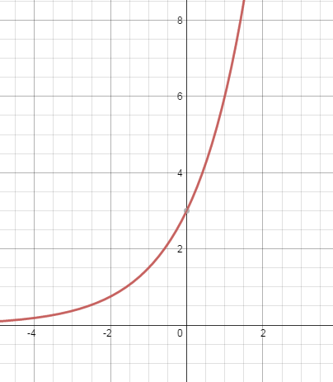
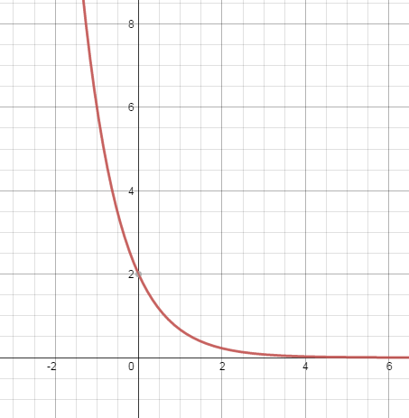
i)
ii)

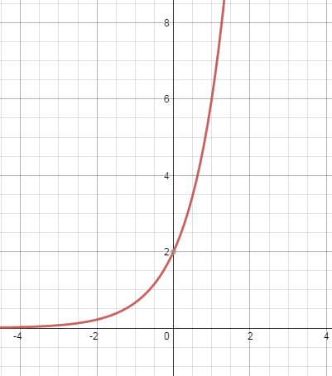
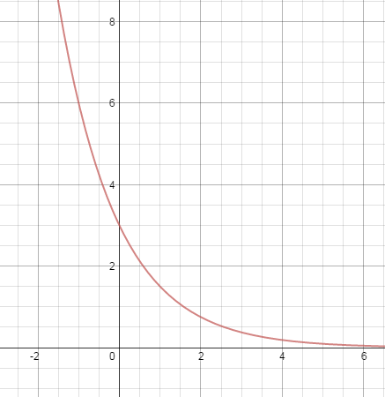
iii)
iv)

48. Gas is currently $2.51 per gallon. Kurt has a 12-gallon tank and is considering filling it up before his road trip, but thinks gas might be cheaper out of the city. Use this information to answer the following questions.

- What is the independent variable? __________________________________________

- What is the dependent variable? __________________________________________

- What is the domain? __________________________________________

- What is the range? __________________________________________

49. You invest $3600 at a bank that pays an annual interest rate of 6%.

- Is this an example of exponential growth or decay? _______________________
- Write the function that represents the situation ___________________________
- How much money will you have after 10 years? __________________________

50. Ashley bought a new car at a cost of $29,700. Each year, the value of the car depreciates at a rate of 11%.

- Is this an example of exponential growth or decay? _______________________
- Write the function that represents the situation ___________________________
- How much will the car be worth after 7 years? __________________________

